Chapter 2: Intro to variables and the basic data types (JavaScript)
“Programming is all about manipulating data”
“Data is information that we store in our computer programs .”
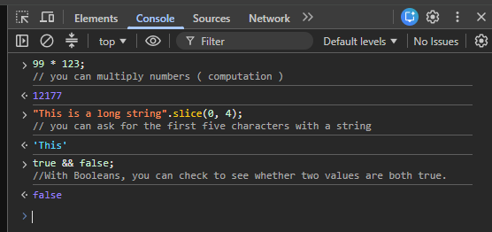

Basic Types Of Data
Numbers- Represent numbers!
Strings- Represent text “”.
Booleans- Represent values that can be true of false
NB!: All data in JavaScript is just a combination of these types of data.
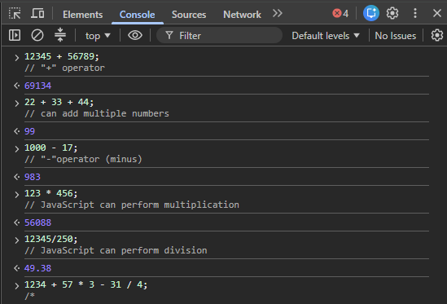
(;)- marks the end of a particular JavaScript command or instruction, e.g “ end of a sentence.”

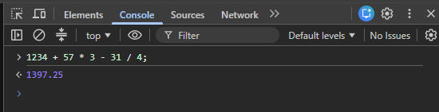
“In math, the rule is that multiplication and division always take place before addition and subtraction, and JavaScript follows this rule as well.”
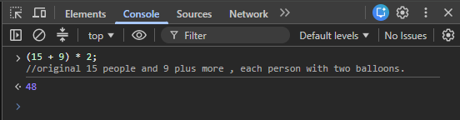
Variables : named storage location that holds data.
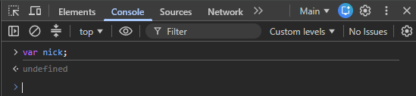
“The Console spits out undefined in response.”
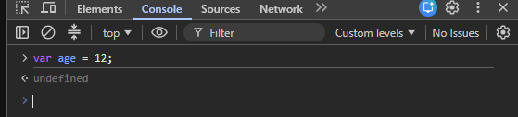

“To give the variable a value, use the equal sign”
Naming Variables & Creating variables using math
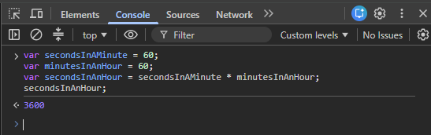
When you name a variable it must have no spaces.
Incrementing_- ++ ( add by 1 )
Decrementing- “—” ( minus by 1 )
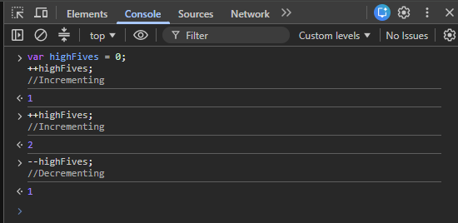

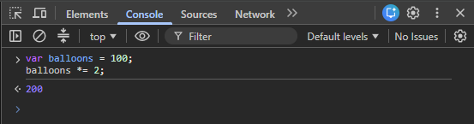
“*= 2”- Multiply by 2
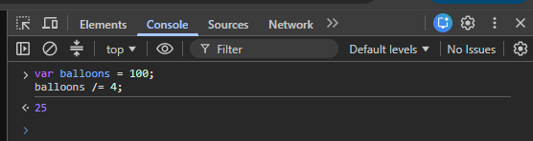
“/=4”- Divide by 4
Strings
“Anything with quotations marks is a string”
Joining Strings
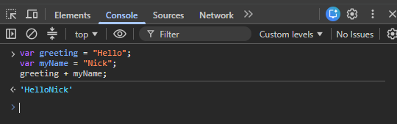
Finding the length of a string
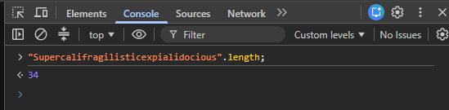

Getting a single character From a String
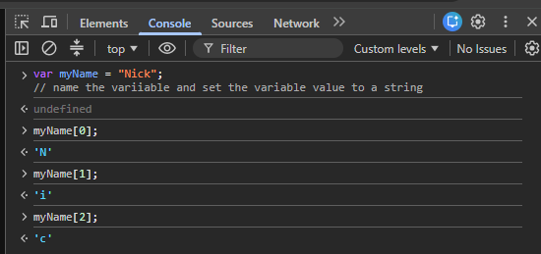
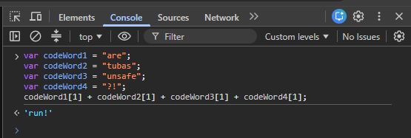
Logical Operators ( Booleans )
&&( And ), || (Or), ! (NOT)
“===”( To find out if two numbers are exactly the same.) “ Ask a question”
“=”( assigns a variable to a value )
“==”( equal-lish ) they look similar.

